FOR PETE’S SAKE
It All Started With A Little Glass of Beer; But Then, So Many Adventures Do -- By Richard Benyo

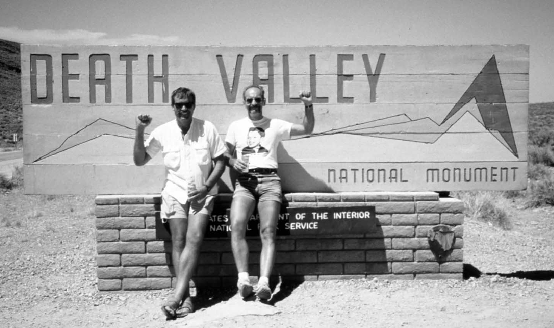

It all started with beer.¹ And ended the same way.

Between lay the opposite ends of a continent, more than three decades, and 300 miles of bad roads and trails.

The first beer came when I was six years young. Surreptitiously--and seemingly ritualisticly--fed to me by Peter Herman, the patriarch of the Herman tribe.

Peter Herman was German. Germans drink beer. Peter Herman drank beer. So did his three sons, Puda (Norbert; Puda pronounced Poo-da), Eppie (Edward), and Richard. My "three musketeer" uncles.

I was special to Peter. I was not just the first male grandson of Peter Herman, but the first grandchild. Period. Still steeped in Old World customs, remnants of the rights of primogeniture, in which the first male offspring inherits the kingdom, I was treated special by Peter Herman. I was treated to Saturday--the holy day in Peter Herman’s week when he had four hours to himself. Which he shared with me and only me.

Peter Herman was the janitor for St. Joseph’s Church in what was then East Mauch Chunk, Pennsylvania. St. Joe’s consisted of a huge church, a rectory, a grade school, a residence for the Sisters of Christian Charity who taught at the school, and a cemetery. The complex took up half a block of our little down-on-itsluck coal town. Peter Herman maintained the property through snowstorms, 5:15 a.m. masses, and annual top-to-bottom cleanings that would have stirred jealousy in a Quaker homemaker.

As a kid, I helped him maintain his own house by cutting grass and hauling ashes from the coal furnace. And was rewarded with shiny coins and with Saturdays.

On Saturdays Peter Herman would draw the shades in the front room, position his comfortable chair toward the clunky black-and-white TV, set up a dining room chair for me to sit next to him, and we’d spend the afternoon watching cowboy movies beamed through the world’s first cable television system from stations in Philadelphia and New York City.

Peter Herman loved cowboy movies. And he had a marathon capacity to watch them. Roy Rogers. Tom Mix. Bob Steele. Hour after hour.

While we watched cowboy movies, Peter Herman drank beer, poured from a frosty bottle into a sixounce glass. One day he brought in two glasses. And poured beer into both glasses. "Here," he said, handing me one. "You’ve got to learn how to drink beer. Wash that trail dust out of your throat."

I tried it and made a face. He smiled; he seldom laughed outright; he was seldom out from under a heavy burden of worries and woes. "You’ll learn to like it," he said, "else you ain’t much of a German." He smiled again, then became serious. "Don’t ever tell your mother about this. This is between you and me."

He never gave me more than a six-ounce glass of beer. I learned to nurse it all afternoon. From the cowboy movies like Roy Rogers’ Saga of Death Valley (also starring Gabby Hayes and Don Barry), I learned about the infamous valley of death. From Peter Herman I learned to drink beer.

We never talked during the movies. The fact that I had become a severe suttterer when I came out of anesthesia early during a tonsillectomy at age five didn’t bother him. After all, we were cowboys; we were supposed to be laconic.

Peter Herman, cowboy movie aficionado, never got to go to the Wild West, much less Death Valley. Hell, Pete Herman never got west of Harrisburgh, Pennsylvania. On a regular basis I told Peter Herman that someday I was going to go to Death Valley. He’d smile and raise his little beer glass and say, "Tell Roy Rogers I said ’Hello!’ And send me a postcard."

At the end of the afternoon, after the cowboy movies ended, he’d raise the shades and limp into the kitchen where Mary Herman, my grandmother, who towered over him, had returned to begin making supper. On the way to the kitchen, he’d slip me a Senz-Senz to cover the beer on my breath. Whichever uncles were around would come by and we’d mosey up the street to the St. Joe’s Club, where they’d drink nickel beers and I’d play the pinball machine. Pete Herman had been crippled in one leg as a child and he limped like a Pony Express rider who’s been in the saddle too long.

He never saw Death Valley. But he lived there once a week. For a few hours. Breathing in the alkali dust, squinting into the furnace sun, free to roam away from Mauch Chunk to find some escape from the mundane, some peace while riding tall in the saddle.

* * * * *
Al Arnold was a big fella. Hulking, like a benign Frankenstein monster. Not your classic concentration camp skinny long-distance runner with spindly arms. And somewhat better looking.

He arrived at the offices of Runner’s World Magazine in Mountain View, California one day in 1977. He’d called ahead. He had a story to tell us; pictures to show us. We were about to introduce a new magazine devoted to marathon running. Marathoning had outgrown itself and our February issue could no longer hold the annual marathoning summary so we were giving it its own quarterly magazine, The Marathoner.

Al had a fantastic story to tell of how he ran from Badwater in Death Valley, the lowest point in the Western Hemisphere, to the peak of Mt. Whitney, at 14,494 feet the highest peak in the Lower 48. In the middle of summer. With temperatures in the 120s. He’d been crewed by Eric Rahkonen, a photographer for the Contra Costa Times. He’d almost died on the mountain when someone stole a cache of warm clothes he hid on the way up.

The 1977 first-ever successful solo crossing of the course had been Al’s third attempt. He’d tried and failed in 1974 and 1975. He’d taken a bye in 1976 to get married.

Athletes had run the course some years before as a relay (In fact, a 16-minute film had been made of such a relay by Bruce Maxwell and Tate Miller; you could buy your very own 16-mm copy from an ad on page 137 of the February 1979 issue of Runner’s World for a mere $195.), but it was felt that no runner was capable of doing the course solo. Big, tough, soft-spoken Al Arnold had proved them wrong.

The feature story in the first issue of The Marathoner (Spring 1978) opened the dam gates. Dozens of runners went to Death Valley each summer to attempt to do what Al Arnold had done.
But it took another four years until another runner succeeded. That runner was Jay Birmingham, who in 1981 ran the course in 75:34; Al Arnold had taken 84 hours to complete the distance.

But Birmingham didn’t merely run the course. He followed it up by writing a book about the adventure, a book he called The Longest Hill, named after the 18-mile-long climb from Stovepipe Wells to Townes Pass, which effectively gets a runner out of Death Valley--and away from the worst of the heat.

Dozens of runners continued to travel to Death Valley each summer and dozens of runners went home crushed.

In 1982 New Zealander Max Telford brought the course record down to 56:33. Greg Morris went to Death Valley in 1983 and completed the course in 76:38.

* * * * *

The next major insanity on the course came in 1986 when, inspired by Jay Birmingham’s book, two Santa Rosa, California ultrarunners attempted to organize an official race on the course, which they called The Longest Hill Ultra. And they almost pulled it off. But not quite.

Tom Crawford, a grade school principal, and Mike Witwer, a medical doctor, were the guiding lights behind the California Untrarunners, and they wanted to put on the ultimate ultra: from Badwater to the peak of Whitney in the middle of summer.

They began getting the word out. They took trips to Death Valley to scope it out and to explore getting the necessary permits. They put together a multi-paged entry form--a rarity in ultrarunning in those days when entry forms were usually one side of one sheet of paper. They wanted to spell out the dangers of the course. Give fair warning of what could be expected. Scare away the timid.
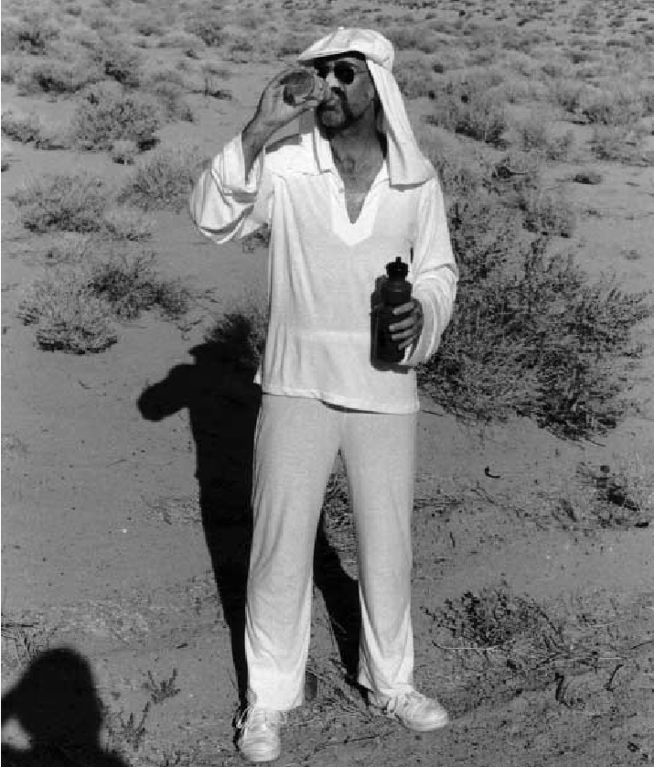

IT AIN’T BEER, but for the meantime, it’ll have to do

Incredibly, they received several dozen entries, many of them runners who’d failed on the course in past years, but who felt that being part of an official race would increase their chances of success. Crawford and Witwer even managed to finagle an insurance agent to write them a policy so that, should something go wrong, they wouldn’t lose their homes--and everything else they owned. But the agent canceled the policy when he got word of some of the inquiries from potential entrants that Crawford and Witwer were fielding. Inquiries such as: Will there be day care available? Inquiries such as: Can I bring my horse?

Without insurance, but with a year’s worth of training behind them (Crawford and Witwer intended to both direct the race and run it, not uncommon in an ultra back in those ancient times.), the California Ultrarunners canceled the official race and on July 4, 1986 the two of them, supported by Witwer’s brother, left Badwater. Some 70 hours and 27 minutes later, they became the fifth and sixth runners to complete the course, although in the process they nearly froze while huddled together in the stone hut on the peak of Whitney where they were trapped overnight after they summited.

* * * * *

When they returned to Santa Rosa, two things happened.

I got a call from Witwer, who wanted publicity for their incredible feat. I was at the time writing on running for the San Francisco Chronicle. I drove over and interviewed them and wrote a story for the newspaper. (They never offered me a beer.) When it was published, it instigated a challenge to Crawford and Witwer from Kenneth Crutchlow, an expatriate Brit who had done all sorts of long-distance challenges over the years (some of them in Death Valley), and who was looking for a new challenge and the accompanying publicity. In a show of typical Crutchlow bravado, he barged into the Bullmoose pizza emporium where Crawford and Witwer were eating, and loudly challenged them to a team race in July of 1987: Crutchlow and a fellow Brit against Crawford and Witwer, representing America. The wager: a pint of English ale.

Crawford and Witwer bit. At first.

Crutchlow put an ad in Athletics Weekly, an English track & field publication, looking for a partner to take on Crawford and Witwer and got but one response. That response, however, was from Eleanor Adams, at the time the best damned female ultrarunner in the world; perhaps even the best ultrarunner of any sex.
When Witwer heard Crutchlow was teamed with a female who might actually kick his sorry ass, he pulled out of the race. So, at the last minute, Crawford enlisted the assistance of Jean Ennis, a fellow Santa Rosan. Both of them were coming off the Western States 100. Both of them quickly changed gears to Death Valley. I was invited to go along to cover the challenge race for the Chronicle. It would be my first trip to Death Valley. Pete Herman would be thrilled.

On the way through Lone Pine, we took a side trip to the Alabama Hills between town and Whitney Portal. Literally hundreds of Westerns had been shot in the Alabama Hills. It all looked very familiar, as it should: I’d spent nearly every Saturday afternoon of my childhood in the Alabama Hills, even if only vicariously. We sat on the tailgate of the truck and had a beer. I thought of Pete Herman and washed down more of the trail dust. The race itself, the first-ever on the Death Valley/Mt.Whitney course, was extremely interesting--not only because of the race itself, but also because of all the activity we encountered.

A week or so earlier, Linda Elam had become the first female to finish the course, and seventh overall. Her running partner, Adrian Crane, also finished the course. Gill Cornell of nearby Ridgeway was on the course when the U.S./U.K. race started and he would ultimately set a new course record of 45:15. There was also an elderly guy from Washington State on the course: Richard Kegley, in his 60s, would become the oldest man to run the course. And David Bolling, a journalist who was covering Crutchlow, and who decided to "run" the course with him in the hopes of doing an inside-rhe-race story on the race, had the opportunity to, with Crutchlow, set the slowest time (126:30) ever recorded on the course, as Crutchlow, bringing up the tail of the U.S./U.K. race went so far as to have his driver take him into town for sit-down meals.

In the real race, which was not run as a relay, but rather as a team race where the times for each team runner added together would constitute the team’s time, Eleanor Adams went out like a shot, while Crawford and Ennis ran together. Eleanor Adams reached the top of Whitney in 52:45, knocking more than 15 hours off Linda Elam’s new women’s record. Crawford and Ennis did 58:57. Scorewise, the American team triumphed. Coursewise, 1987 was the year the course came into its own:
1. First woman to finish the course (Elam).
2. New course record (Cornell).
3. Oldest finisher (Kegley).
4. First race on the course (U.S. vs. U.K.).
5. New women’s record (Adams).
6. Slowest time on the course (Crutchlow & Bolling).
7. Most successful crossings (9; more than in the entire previous history of the course).

* * * * *

Almost a year to the day of the U.S./U.K. race, Crawford threw a party on his deck in Santa Rosa. Most of the U.S./U.K. team members (runners and crews) were there. As the night wore on and the beer flowed, I hatched a very fateful theory: If you do the one-way course, from Badwater to the peak of Whitney, in order to get off the course, you have to descend a dozen miles on foot to get to Whitney Portal before you can get to a paved road--and a car. Aren’t you, in effect, already started on a return trip to Badwater? Why not just keep going?
Besides relaxing a person, beer can make the world seem so much simpler. Life had been so much simpler sitting in Pete Herman’s darkened livingroom watching Western movies. The reality of Death Valley was nothing like Western movies portrayed. Life was that simple. Everything was black and white. And easy.

Even though it was night and dark, Crawford was wearing cheap plastic sunglasses. "Well, hell," he said. "Let’s go do it--!"

"Do what?" I asked. Too much beer can also make a person stupid.

"Let’s go do the out and back--next year. At this time." He nodded his head up and down as though this were the most natural suggestion in the world. "You said it yourself," he pushed. "Coming down off the mountain, you’re already on your way back to Badwater. Let’s just keep going."

What I didn’t want to mention, what would have spoiled the moment, was the fact that I’d never even done the course in one direction, much less two; I sucked when it came to running in heat; and I didn’t do very well at altitude.

"Well, OK," I said. "We’ll do it."

Crawford lowered his sunglasses. "Look me in the eye and say that--"

"OK, we’ll do it," I said, and suddenly the beer I’d drunk that night turned bitter in my belly.

The next morning, the phone rang. It was Crawford. "Did we say last night what I think we said--?"

"You mean about doing the Death Valley course out and back?" I supplied.

"Yeah, that--"
"We did," I admitted.

There was a pause. "Did anybody hear us?"

"Couple people," I supplied, feeling at this point that Crawford deserved everything he got for saying it loud enough for even us to hear.

"Well, then--" he eventually said. "Well, then, I guess we gotta do it."

And we did.

* * * * *

We trained for a full year to do the out-and-back in 1989. In 1988, while Crawford and I were drinking too much beer and getting ourselves into potentially lots of trouble, the Hi-Tec shoe company staged a race on the course with eight runners, four of them racing to the top of Whitney, after they were told weeks in advance by the rangers that there were no official races allowed on the National Forest lands. The runners who made it to the top were cited by ranger Marty Hornick, quite an athlete in his own right--he held the record for traveling on foot from Whitney Portal to Whitney’s peak. We closely followed the activity on the course throughout the summer of ’88, but the activity didn’t match ’87’s insanity.

Our concerns for the out-and-back were simple: We could die. So everything we did was aimed at preventing just that occurrence.

Hell, it wasn’t that long before that a two-person relay team claimed that no human being would ever solo it; and it was now a mere 12 years since Al Arnold had done just that. Now Crawford and I, two less-than-stellar runners, both with marathons right around the threehour mark, were going to commit aerobic suicide.
Of course we needed a team to watch us die.
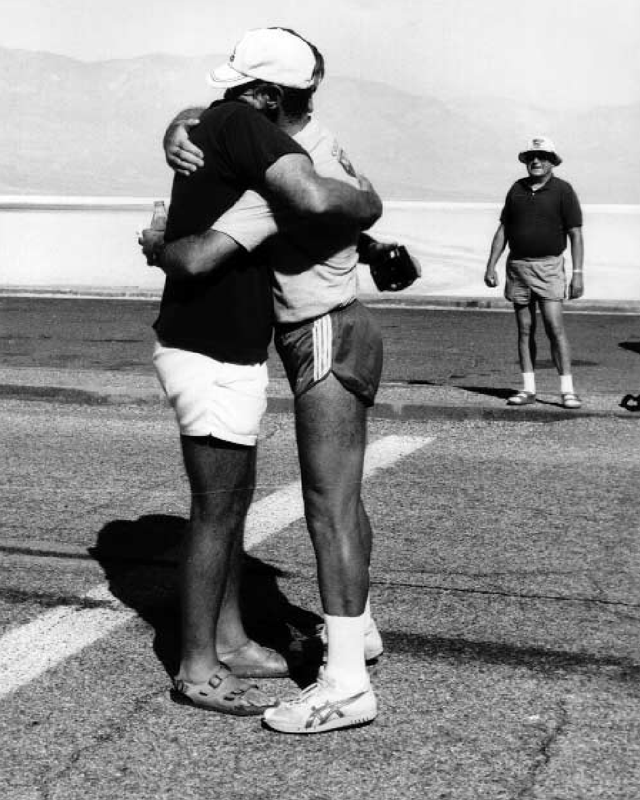

With no worries about their manliness, Crawford and Benyo enjoy a bearhug at the finish

Tom’s wife’s uncle, Billy Owens, a grizzled World War II marine who’d spent three years landing on Japanese held islands, said he’d help--but only if Crawford and I joined ECV (known as The Clampers), an all-male group of Western historians, who, like the Hash House Harriers in running, were either historians with a drinking problem, or drinkers with an historic problem. We went through the initiation in June and are still members. It’s a deal similar to the U.S. Marines and alcoholics: once you are, you are--for now and forever.

I recruited my wife, a nurse anesthetist, to be my crew chief, and she in turn recruited Ed and Niki Hengenius, she a recovery room nurse and Ed an engineer at Lockheed.

Tom recruited his wife Nancy and Carol Cognata, both teachers, who could fit the race into their summer vacations, as well as the aforementioned Uncle Billy. Crawford and I lived 45 minutes away from each other so we trained alone. Doing 36-mile workouts on Saturday, followed by 25-mile workouts on Sunday to teach our bodies to recover while still working. Crawford did workouts in a dry sauna at a health club; I didn’t live near a health club so I had a hotbox built, installed electric heaters, and worked out in it as noon as it sat in the pasture absorbing heat from the sun on the outside and from the electric heaters inside.

Our social lives went to crap. Other than work each day, the rest of our time was spent training. And worrying.

Two weeks before the fateful day, we spent a week camped outdoors at Panamint Springs, doing 4-6-hour workouts around high noon.

When the day of the "race" arrived, we lined up at the crosswalk on the road in front of Badwater, Uncle Billy sent us off, and many days later we returned, sort of safely. Tom had a wonderful day on the top of Whitney and began dying near the Darwin turnoff on his return trip, as he began urinating blood. While he sat in a folding chair rehydrating, he watched the storm roiling on the top of the mountain, worrying about my sorry ass, which was caught in the middle of a lightning storm that snuck up on us from behind.

Tom finished the out-and-back course in 126 hours and 34 minutes.² I finished in 170 hours and 58 minutes.

Tom helped crew me on the final miles, but kept pushing Pepsis down me, which provided sugar and caffeine but also made me suffer diarrhea every halfmile. When I finally reached Badwater, Tom pushed me into his little Isuzu Trooper II. There was a Styrofoam ice chest on the floor in front of me. Nestled in ice was a six-pack of Coors Light, Tom’s favorite beer. He yanked one out, popped the tab, and handed it to me. "Here!" he said. "Drink this down. I expect them all to be gone before we reach Panamint Springs." He popped the clutch, the little engine caused the rear wheels to make a little squeal, he pulled a beer for himself from behind the driver’s seat, popped it, and downed half of it. "We’re getting the hell out of here and we ain’t ever coming back. I ain’t ever coming back to this sinkhole."
Two years later both of us were back, Tom to attempt a fast one-way, me to attempt to improve my out-and-back time. Both of us failed, Tom at Whitney Portal, me 26 miles from the finish at Badwater. We had a few more beers to commiserate.

¹ Born-again-newly-sober folks need not waste their time or a 37-cent stamp sending irate condemnations denouncing people who drink alcohol when they spent way too much time abusing what we’re merely using.

² I won’t draw out the whole adventure, as it is more than adequately covered in The Death Valley 300: Near-Death and Redemption on the World’s Toughest Endurance Course, and if you buy a copy, I’ll be able to make some space in my garage--for more beer.

